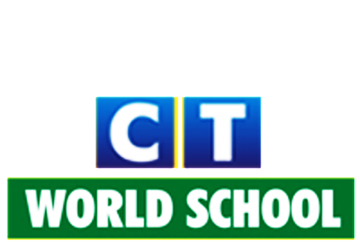
Connecting Life and Learning
Syllabus of KG I

Language (literacy)
Writing skill: Introduction and identification of small letters a-z
Objects related to each other
Matching with pictures and capital to small
Missing Letters
Dictation
Before, after and between
Vowel words

Speaking skill: Phonic drill Vocabulary
Self-introduction
General communication
Rhymes

Listening skill: Stories
Understand correct pronunciation

Reading skill: Will be able to identify letters and alphabets
Will be able to read simple words

Numeracy
Pre-maths concepts: Big-Small
Tall-Short
More-Less
Heavy-Light
Inside-Outside
Before-After
Full-Empty
Far-Near
Long-Short

Writing skill: Forward counting (0-100)
Dodging (0-100)
Missing numbers (0-100)
Backward counting (40-0)
Before, after and between numbers (0-50)
Complete the pattern
Count and match
Count and write/tick/circle

Speaking skill: Forward counting (0-200)
Backward counting (40-0)

General awareness and EVS
- Myself
- Seasons
- Colours
- Plants
- Fruits
- Flowers
- Vegetables
- Animals
- Birds
- Vehicles
- Good habits
- Shapes
- Safety
- People who help us
- Computer

Hindi
- Introduction and identification of swar (A’ A:)
- Objects relayed to each letter
- Hindi rhymes.

Art and craft
- Freehand
- Hand printing
- Vegetable printing
- Tracing
- Tear and paste
- Paper folding
- Origami
- Spray paint
- Sponge paint
- Spot the difference

Performing art
- Zumba
- Kathak
- Bhangra
- Garba
- Freestyle

Physical activities
- Yoga
- Outdoor activities
- Meditation, Yoga and Aerobics

