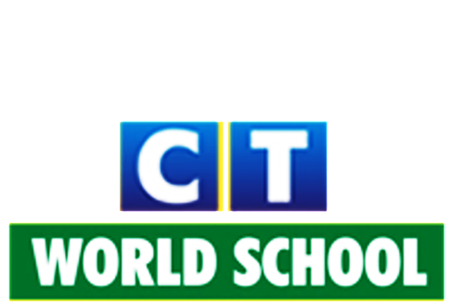

Connecting Life and Learning

Grade IV
Syllabus of Term-2

English
Writing: Process writing, Paragraph writing
Grammar: Prepositions, Simple Future Tense, Adverbs (Manner, Time)
Poetry: Trees
Literature: Irah becomes a flower gardener, The Olympic games, A fairy with horns

Hindi
Literature: आंखों की देखभाल
मेहनत की कमाई
लालची बंद
सच्चा डॉक्टर
हमारी जिम्मेदारी
घुड़सवारी कैसे सीखे
Grammar: सर्वनाम, क्रिया, विशेषण, विलोम शब्द, अनेक शब्दों के लिए एक शब्द, पर्यायवाची, अनुच्छेद लेखन, औपचारिक पत्र,प्रत्यय,लिंग भेद, उपसर्ग

Science
Ch5: Food: Our basic need
Ch6: Digestion and role of microbes
Ch9: Solids, Liquids and gases
Ch10: Force, work and energy
Ch11: The Solar System

ICT
Ch6: Style a word document
Ch8: Create a presentation: Power point 2010
Ch9: Design a presentation

Mathematics
Ch6: Fractions
Ch8: Geometry
Ch10: Metric Measures
Ch11: Perimeter and Area
Ch12: Money

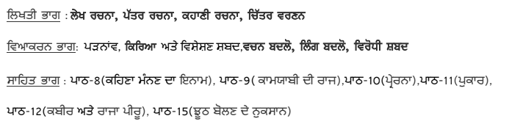
Punjabi

