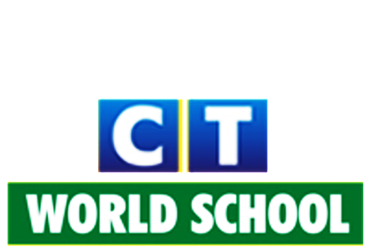

Connecting Life and Learning

Grade VI
Syllabus of Term-2

English
Literature: Ch: The Festival of Eid
Ch: The Eagle has landed
Ch: Birds and Salim Ali
Ch: The adventures of Robin Hood
Poetry: Laughing Song
To a butterfly
Writing: Email writing, Essay writing
Grammar: Transitive and intransitive verbs, Sentences, Connectors

Hindi
Literature: जन्मदिन के बहाने,
विशेष पुरस्कार
संसार पुस्तक है
दो कलाकार
बापू का सपना
पंच परमेश्वर
Grammar: पर्यायवाची ,अनेकार्थी ,औपचारिक पत्र, उपसर्ग प्रत्यय, अनुच्छेद लेखन ,संवाद लेखन ,क्रिया, विशेषण, क्रिया विशेषण, संवाद लेखन, अनुच्छेद लेखन, औपचारिक पत्र लेखन, वाक्य संशोधन

Science
Ch: The living organism and their surroundings
Ch: Motion and measurement of distance.
Ch: Light, shadows and reflections.
Ch: Electricity and circuits
Ch: Magnetism

SSC
History: Ch7: Rise of New Ideas and Religions
Ch8: The First Empire and Ashoka
Geography: Ch7: India – Location, political and physical divisions
Ch8: Climate of India
Civics: Ch4: Democratic government
Ch5: Panchayati Raj
Map work- Geography and Hostory

ICT
Ch:5 Edit cell content
Ch:6 Formatting a worksheet
Ch:8 Algorithm and flowchart
Ch:9 Coding club: QBASIC

Mathematics
1. Integers
2. Introduction to Algebra
3. Algebraic equations
4. Basic Geometrical Ideas
5. Understanding Elementary Shapes
6. Perimeter and area
7. Comparing Quantities

Punjabi
ਲਿਖਤੀ ਭਾਗ : b/y ouBk, gZso ouBk, ejkDh ouBk, fuZso toDB
ਵਿਆਕਰਨ ਭਾਗ : fefonk , ਵਿਸ਼ੇਸ਼ਣ, ਕਾਲ, w[jkto/, ਬਹੁਤੇ ਸ਼ਬਦਾਂ ਦੀ ਥਾਂ ਇੱਕ ਸ਼ਬਦ, fbzr pdb', fto'Xh Ppd, nP[ZX P[ZX
ਸਾਹਿਤ ਭਾਗ: ਪਾਠ-9(ਚੰਦਨ ਦੀ ਮਹਿਕ),ਪਾਠ-10(ਸਾਡੀ ਸਭ ਦੀ ਧਰਤੀ),ਪਾਠ-11(ਉੱਡਣਾ ਸਿੱਖ),ਪਾਠ-12(ਕਰਤੱਵ ਦੀ ਪਾਲਣਾ),ਪਾਠ-13(ਦੇਸ਼ ਪਿਆਰ) ਪਾਠ-17(ਅੰਧਵਿਸਵਾਸ਼),ਪਾਠ-18(ਖ਼ਾਸ ਮਹਿਮਾਨ)

