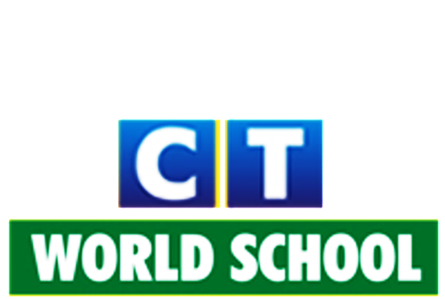

Connecting Life and Learning

Grade VII
Syllabus of Term-2

English
Literature: Ch: Fire in the forest
Ch: How I taught my grandmother to read
Ch: Boyhood days
Ch: The Bermuda Triangle
Ch: The Blue Carbuncle
Poetry: Nine Gold Medals
Throwing a tree
Writing: Article writing, Email writing, Note-making, Dialogue writing, Diary entry.
Grammar: Active and passive voice, Reported speech, Use of ‘For’ and ‘Since’,
Prepositions, Mixed tenses
Book- Alice’s Adventures in Wonderland

Hindi
Literature: प्राकृतिक व्यायाम
डॉक्टर के शब्द
डिजिटल इंडिया
एक रानी का बदला
नमक का दरोगा
Grammar: क्रिया, विशेषण, क्रिया विशेषण, स्वर संधि, पर्यायवाची, अनेक शब्दों के लिए एक शब्द,
औपचारिक पत्र , संवाद लेखन, उपसर्ग , प्रत्यय, अनुच्छेद लेखन!

Science
Ch: Respiration in organism
Ch: Transportation in animals and plants
Ch: Reproduction in plants
Ch: Time and motion
Ch: Light

SSC
History: Ch7: Tribal communities and their development
Ch8: Devotional Paths and Religious Movements
Geography: Ch5: Air Composition and Structure
Ch6: Weather and climate
Civics: Ch4: Gender issues
Ch9: Towards Equality
+Map work

ICT
Ch:6 Website designing: HTML basics
Ch:7 Website designing: HTML next steps
Ch:10 Coding club: Python Basics
Ch:11 Coding club: Next steps

Mathematics
Ch: Lines and angles
Ch: Triangles and its properties
Ch: Comparing quantities
Ch: Rational numbers
Ch: Perimeter and area
Ch: Algebraic expressions

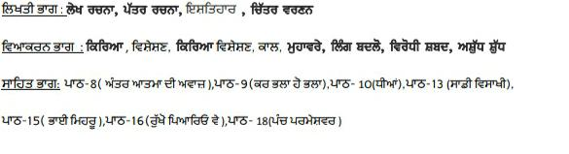
Punjabi

