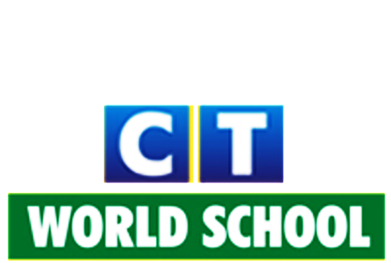

Connecting Life and Learning

Grade VIII
Syllabus of Term-2
English
Literature: Waiting for the rain
The diary of a young girl
The choice is yours
Poetry: Her head
Skater
Writing: Biography, Email, Story
Grammar: Connectors, Clauses (Independent and dependent), Sentences (Simple,
compound, complex).

Hindi
Literature: कर्मवीर
प्रदूषित हवा हर सांस में
वीर अभिमन्यु
जादुई कालीन
असाध्य एड्स
सभ्यता का रहस्य
Grammar: सर्वनाम, क्रिया, विशेषण, क्रिया विशेषण, अनेक शब्दों के लिए एक शब्द, अनुच्छेद लेखन,
औपचारिक पत्र ,प्रत्यय, अलंकार, समास, अपठित गद्यांश तथा पद्यांश!
Science
Ch: Reproduction in animals
Ch: Reaching the age of adolescence
Ch: Friction
Ch: Sound
Ch: Light
Ch: Chemical effects of electric current

SSC
History: Ch11: Rise of Indian Nationalism
Ch12: The March to Freedom (1919-1947)
Geography: Ch7: Mineral and Power Resources
Ch9: Human Resources
Civics: Ch5: The Indian Judiciary
Ch7: Understanding and tackling marginalization
+MAP WORK

ICT
Artificial Intelligence: Introduction
How does AI work?
Applications of AI
Future of AI
The AI games
Terabytes: Visual Basic
Coding Club: Java Basics
Programs of Java

Mathematics
Ch: Understanding Quadrilaterals
Ch: Comparing Quantities
Ch: Algebraic Expressions and Identities
Ch: Mensuration
Ch: Factorization
Ch: Direct and inverse proportion
Punjabi

