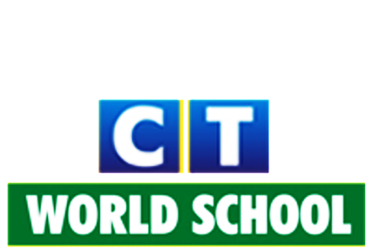
Connecting Life and Learning
Syllabus of KG II

Language (literacy)
Writing skill: Phonic Drill
Vowels words (Three Letter Words)
Demonstratives (This-That, These-Those)
Rhyming words
Dictation
Introduction of basic prepositions
Picture reading
Days of the week

Listening/speaking skill: Three letter words (vowels)
Vocabulary words (related to the topic)
Self-introduction
Simple sentences
Blends (cl, pl, gr, br, ch, sh)
Rhymes
Stories (with sound vocabulary)

Reading skill: Revision of jolly phonic
Reading of three letter words with combination of sight words
Sentence reading
Picture reading

Understanding the shapes: Circle
Square
Rectangle
Triangle
Semi-circle
Oval
Cone
Star
Heart

Numeracy
Pre-maths concepts: Big, bigger, biggest
Tall, taller, tallest
More-less
Heavy-light
Full-empty
In-out
Right-left
Front-back

Writing skill: Forward counting (1-200)
Backward counting (100-1)
Before, after (1-100)
Between number (1-100)

Number names (1-20)
Addition (with pictures and songs)
Greater than, less than (1-100)
Introduction of currency

Speaking skill: Forward counting (1-200)
Number names (1-10)
Table of 2

General awareness
- Myself
- Seasons
- Animals
- Festivals
- Transport
- Our helpers
- Important days
- Parts of the plant
- Healthy-unhealthy food
- Awareness about our country

ICT
- Introduction of computer
- Parts of a computer.

Hindi
Writing/speaking: Swar
Vyanjan

Punjabi
Writing/speaking: Varanmala
ੳ ਤੋ ਣ ਤੱਕ

Art and craft
- Spray painting
- Magic painting
- Vegetable printing
- Craft activity
- Colouring
- Tear and pasting
- Blow painting
- Paper folding craft
- Project making

Physical activities
- Yoga
- Dance
- Zumba
- Skates
- Outdoor activities
- Meditation

Environmental science
- Talking about all types of transport as well as providing a demonstration.
- Introduction to traffic rules and safety.
- Project on living and non-living things.
- Introduction to air, water and noise pollution.

